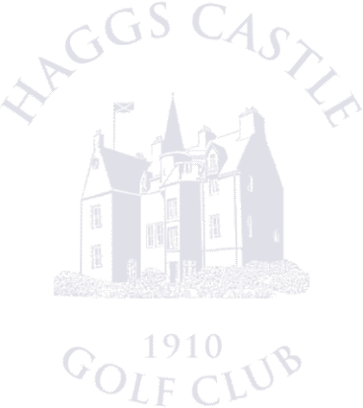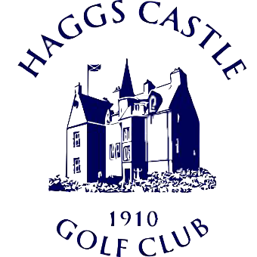Cameron Corbett Vase Entry Form
Saturday 8th & Sunday 9th July 2023
Last Entries: Monday 26th June

Name: Address: _

Telephone: _ _ Email: ___ _
Date of Birth: __________________________ Post Code: _____________________________

CDH Number: _ Home Club:
Exact Handicap Index (Max of 2): _ Preferred Tee Time: _

Competition Entry Fee: £55
Card: Email or post entry form, for payment call the office on 0141 427 1157
Cheque: Payable to Haggs Castle Golf Club, hand in or post with entry form addressed to the Match & Handicap Secretary (club address below)
Bank Transfer: Please quote ‘CCV’ and your name on the reference (e.g. CCV John Smith) (Sort Code 80-07-67, Acc. No. 00384342)

I HEREBY DECLARE THAT I HAVE READ AND WILL UNDERTAKE TO CONFORM TO THE RULES OF HAGGS CASTLE GOLF CLUB AND THE RULES OF AMATEUR STATUS

Signed: __ _ Date: _ _

Haggs Castle Golf Club
70 Dumbreck Road, Glasgow, G41 4SN www.haggscastlegolfclub.com
0141 427 4380 (option 3)
Match & Handicap Secretary handicaps@haggscastlegolfclub.com

