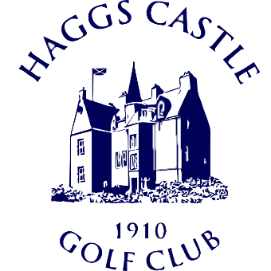
Cameron Corbett Vase Entry Form
Saturday 3rd & Sunday 4th July 2021
Last Entries: Wednesday 23rd June
Name:________________________________
Telephone:_____________________________
Email:_________________________________
Address:___________________________________________________________________________________________
Post Code:___________________

CDH Number:___________________________
Home Club:____________________________
Exact Handicap Index (Max of 2):___________
Preferred Tee Time:_____________________

Competition Entry Fee: £50
Cheque: Hand in or post with entry form addressed to the Match & Handicap Secretary
(club address below)
Bank Transfer: Please quote ‘CCV’ and your name on the reference (e.g. CCV John Smith)
(Sort Code 80-07-67, Acc. No. 00384342)
Card: Pay over the phone (number below) Hand in or post entry form (club address below)

I HEREBY DECLARE THAT I HAVE READ AND WILL UNDERTAKE TO CONFORM TO THE RULES OF HAGGS CASTLE GOLF CLUB AND THE RULES OF AMATEUR STATUS

Signed:___________________________________ Date:_____________________

Haggs Castle Golf Club
70 Dumbreck Road, Glasgow, G41 4SN
www.haggscastlegolfclub.com
0141 427 4380 (option 3)
Ken Perston, Match & Handicap Secretary
handicaps@haggscastlegolfclub.com

